Inserting rows into table dim_stores. After running the procedure it inserted the data in the table.

Here is the screenshot:

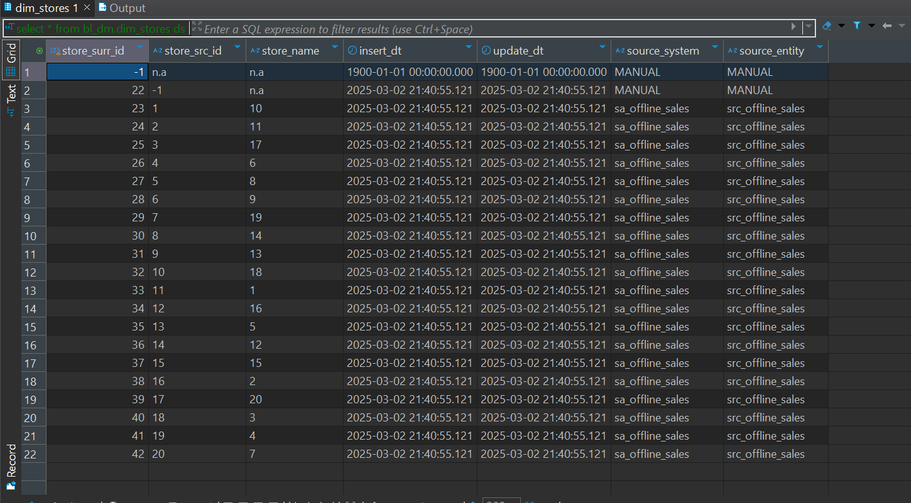

After running procedure second time the output is like this:

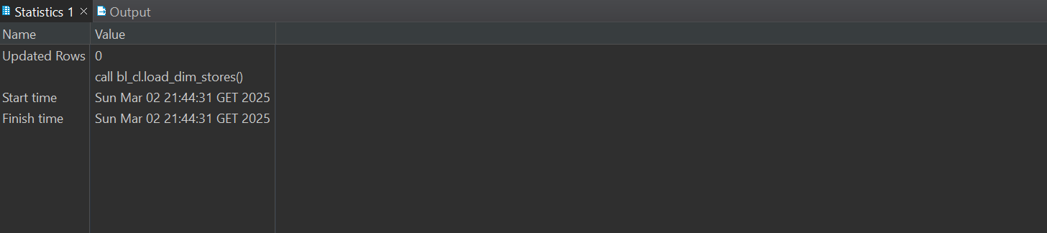

This is the output of log table after first insert-



Rows_affected is one because whole insertion is counted as one whole insertion and it not counts just rows.

And it is after second insertion:



Data loading process: at first I created a function which returns a table and I fill the data from the table of 3nf ce_stores. After I load the data from that table then I use procedure to insert it in dm layer. I use rec which is a record type and I will use it In for loop ,I also declare ‘affected_rows’ since I need to count how many rows were inserted. And last one Is ‘store_cursor’ and I use that cursor to go through the data that my function returned from the above. After that I just insert the default row and before the insert of other stores I check if this store name is changed. If yes then I update its name and also update the column ‘update_dt’ since it is scd1 table nothing more is necessary here and I think that’s it for this table.

Table dim_addresses

After insertion data looks like this:

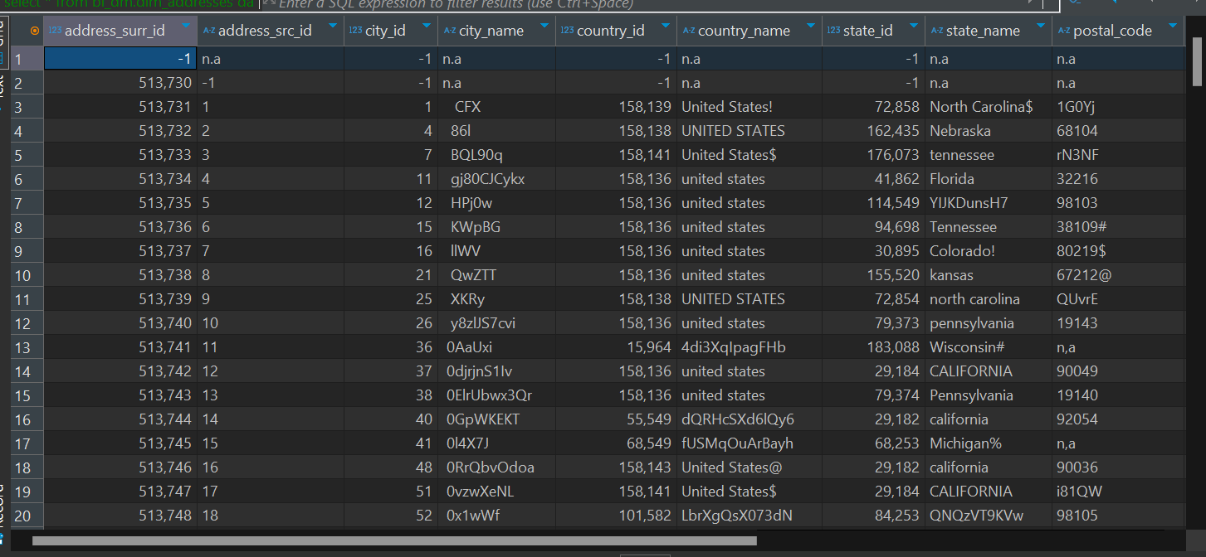

After running procedure second time updated rows is 0.

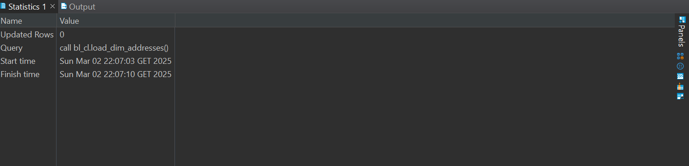

This is how log table looks like:



Data insertion: here logic is different. I have only one procedure and I do both loading and inserting into the table. at first I insert default row and after that I create temporary table,purpose of this is to took the data from 3nf ce_addresses table. after that I create another temporary table and use window function row_number for deduplication purposes. After that I check if something is changed,for example city_name. if something is changed from the source then I update the row and set ‘update_dt’ to now().

After that I just insert data in the table and that’s it. Update logic is correct but my dataset is bad and I have to work on that, I have to add some columns and have to clean it. I will show that it works for customers table.

Dim_customers:  
after insertion data looks like this:

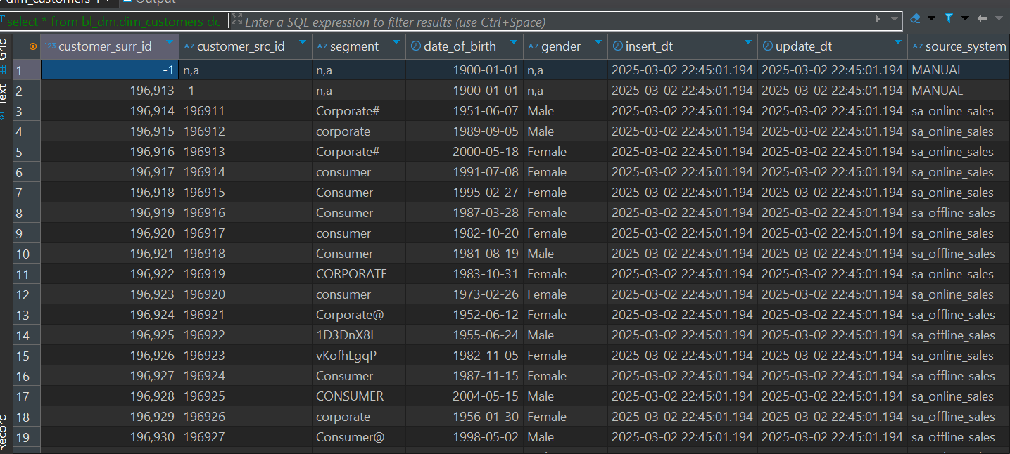

After calling the procedure second time it shows 0 updated rows.

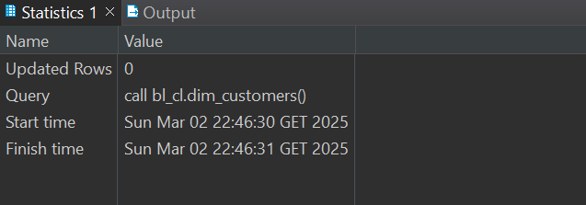

After calling the log function output looks like this:



At second insert nothing was inserted there.

Data insertion: here everything is basically same but one difference is that I use dynamic query here.

And after that I use for loop to insert data in the table.

I will update one row in the bl_3nf.ce_customers table. and check if it will be updated in the dim_customers too.

Query is like this-

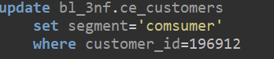

In the dataset its value is corporate and I try to update it in ce_customers. My update logic is like this, if something is changed in source it will be inserted in the table as new value. But since I update it in the table and not in the source its value should not be changed, but update_dt should be updated.



As it seems update is correct since update_dt is changed and segment value is the same.

After that I ran this code second time without updating the ce_customers.now we have to check if it’s updated in dim layer. Its value should be consumer and update_dt should be this time.



As we can see it is correctly updated in the dimensional layer too so it works correctly.

Dim_products:

After insertion data looks like this:

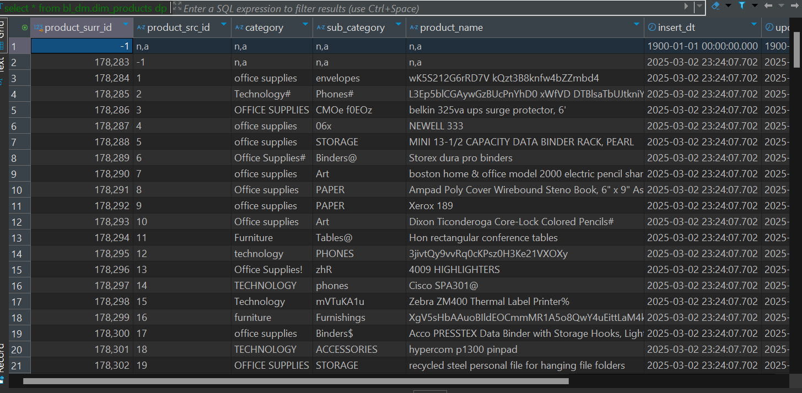

after running procedure second time data looks like this:

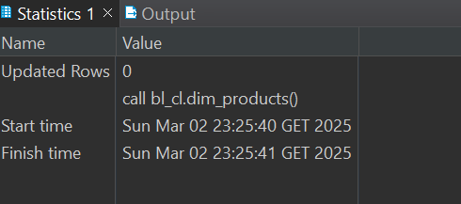

And log table output is like this:



Data insertion logic is basically same as it was in the address table. I insert default row first after that I create temporary table to get the data from ce_products table. after that I create second temporary table for deduplication purposes. After that I check if some value differ in those two tables and if yes I update it. After finally updating and getting data from the tables I insert those rows in the dim_products table. after that I drop these 2 temporary table to make this procedure rerunnable.

Dim_employees_scd

After insertion data looks like this:

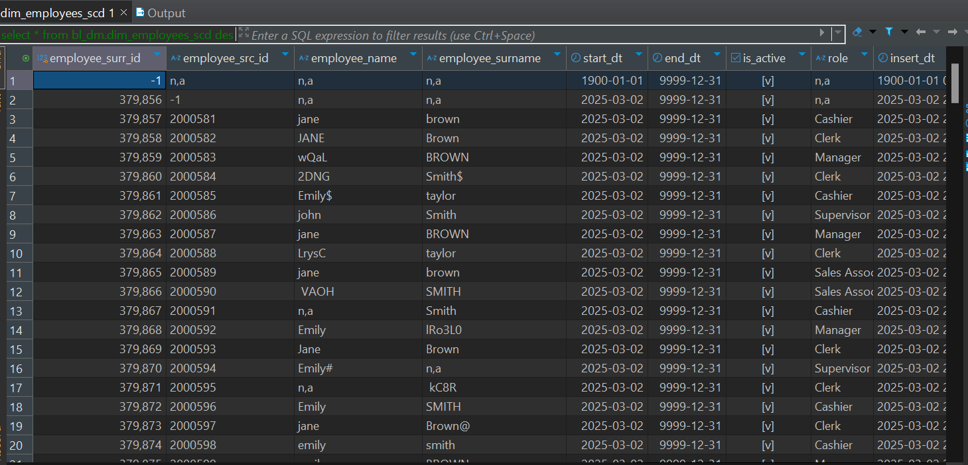

After calling the procedure second time:

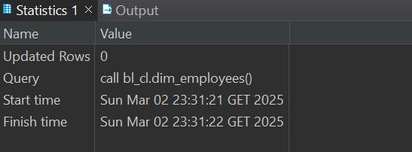

And checking the log table output:



Insertion and loading logic is same as it was in products table.

I update some data in the ce_employees and lets see how update logic works.

Query looks like this:

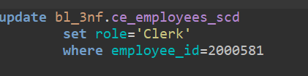

And after running the procedure second time at dimensional layer we can see that log table shows that 1 new row is inserted. 

And lets see how values are changed:





And we can clearly see the difference between these 2 rows.



Scd2 logic works correctly.